# GLAB 330.2.2 - Standard Deviation

# 

**Introduction:**

**Standard Deviation** **(*σ*)** in statistics, typically denoted by **σ**, is a measure of how much a data set varies (dispersion) between values in a set of data. The lower the standard deviation, the closer the data points tend to be to the mean (or expected value), **μ**. In this lab, we will demonstrate how to calculate the standard deviation.

## Learning Objective:

By the end of this lab learners will be able to calculate the standard deviation.

**Given Dataset**

Imagine that we have the following data set representing the number of books read by five learners in a month:

| **Number of Books (X)** |
| --- |
| 2 |
| 4 |
| 4 |
| 4 |
| 5 |
| 5 |
| 7 |
| 9 |

mY New Dataset

Friend/#of Pets

| **Friend Name** | **Number** |
| --- | --- |
| Alice | 3 |
| Bob | 3 |
| Carol | 4 |
| David | 0 |
| Emily | 4 |
| Frank | 0 |
| Grace | 2 |
| Henry | 3 |
| Crazy Aunt Irene | 46 |
| Jack | 3 |

**Instructions:**

Here are the steps to calculate the standard deviation:

1. **Calculate the mean (average) of the data set:**



3+3+4+0+4+0+2+3+46+3=68

68/10=6.8 = mean (average)

Mode = 3 (most frequent)

Median = 3 (middle number when arranged from smallest to largest)

1. **Calculate the squared differences from the mean for each data point:**

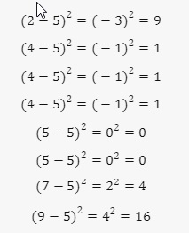

(3-6.8) = -3.8*-3.8=14.44

(3-6.8) = -3.8*-3.8= 14.44

(4-6.8) = -2.8*-2.8= 7.84

(0-6.8) = -6.8*-6.8=46.24

(4-6.8) = -2.8*-2.8=7.84

(0-6.8) = -6.8*-6.8=46.24

(2-6.8) = -4.8*-4.8=23.04

(3-6.8) = -3.8*-3.8=14.44

(46-6.8) = 39.2*39.2=1536.64

(3-6.8) = -3.8*-3.8=14.44

+4+0+4+0+2+3+46+3

1. **Calculate the average of these squared differences (variance):**

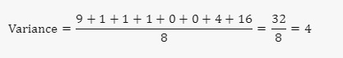

14.44+14.44+7.84+46.24+7.84+46.24+23.04+14.44+1536.64+14.44**=1725.6 (sum of the squared differences**

**1725.6/10=172.56 = variance**

1. **Take the square root of the variance to get the standard deviation:**

## 

Sqroot of 172.56 = 13.13

The standard deviation of the number of books read by these students is **2**. This means that on average, the number of books read by each student deviates from the mean by **2** books.

**Canvas Submission Instructions:**

* Upload your project to your GitHub account without setting it to private.
* Utilize the `README` file for any necessary additional instructions.
* Incorporate suitable comments throughout your project.
* Share the GitHub link on Canvas by clicking on the "Start Assignment" button located in the top-right corner of the Assignment page.